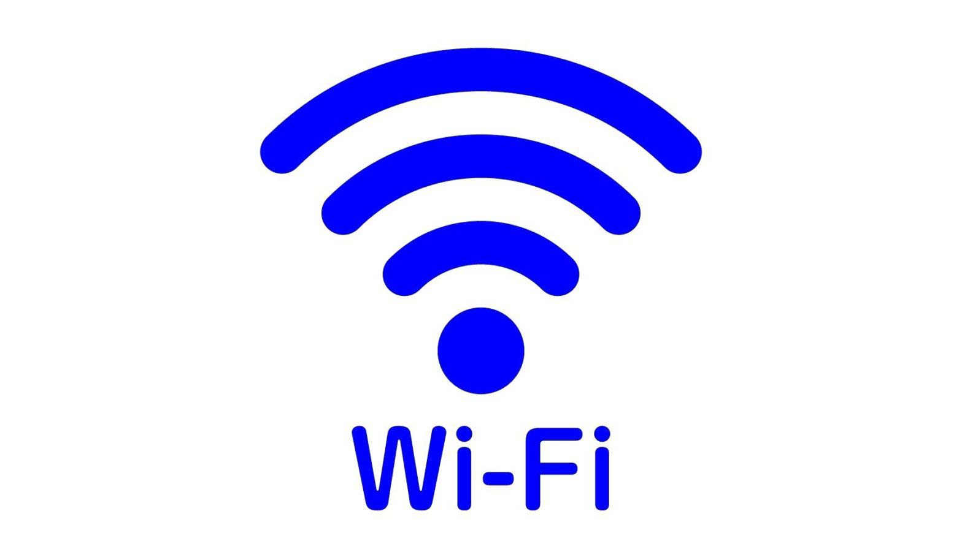
Wifi
Wi-Fi is a wireless networking technology that allows devices such as computers (laptops and desktops), mobile devices (smart phones and wearables), and other equipment (printers and video cameras) to interface with the Internet. It allows these devices--and many more--to exchange information with one another, creating a network. Wi-Fi is one of the most popular wireless or unguided communication technology that uses radio waves to transfer data or provide high-speed internet.

Advantages of Wifi

1 Convenience
WI-Fi can be used at home, at work, at school, and public places.

2 Accessibility
Wi-Fi can be accessed by many devices at once depending on its strength and capacity. A lot of people can access public Wi-Fi at cafes, malls, and transportation.

3 Expandability
It’s easy to serve increasing number of a client without adding additional equipment.

Disadvantages of Wi-Fi

1 Security
Security issues is a disadvantage of Wi-Fi network. If not secured properly people can access the private network and steal information and even use your network for bad purposes.

2 speed
Data transfer rate decreases (to individual computer) when number of clients or computers connected with wifi network increases.

3 Range
Wifi devices operate in full functionality and without any interruptions when they are within the range of AP and receiving good signal strength. WiFi access is limited to about 30 to 100 meters

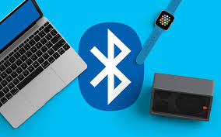
Bluetooth

Bluetooth is a wireless technology that allows the exchange of data between different devices. While Bluetooth uses wavelength to transmit information, it generally only works
Within a short distance for the devices to stay connected. The purpose of Bluetooth is to replace the cables that normally connect devices, while still keeping the communications between them secure

Advantages
- It avoids interference from other wireless devices.

- It has lower power consumption.

- It is easily upgradeable.
- Bluetooth devices are available at very cheap cost

Disadvantages

- If installed on a cellphone it is prone to receiving cell phone viruses

- It only allows short range communication between devices

- It can only connect two devices at once

- It can lose connection in certain conditions

Difference Between Bluetooth and Wifi

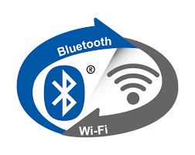
COMPARISON | BLUETOOTH | WIF
Hardware requirement | Bluetooth adapter on all the devices connecting with each other. | Wireless adapter on all the devices of the network and a wireless router.
Ease of Use | Fairly simple to use and switching between devices is easier. | It is more complex and requires configuration of hardware and software.
Range | 10 meters | 100 meters
Security | Less secure comparatively | Security features are better. Still, there are some risks.
Frequency range | 2.400 GHz and 2.483 GHz | 2.4 GHz and 5 GHz
Flexibility | Supports limited number of user | It provides support for a large number of users

